Ann. Bot. Fennici 43: 321–337 ISSN 0003-3847
Helsinki 24 October 2006 © Finnish Zoological and Botanical Publishing Board 2006

Pinguicula (Lentibulariaceae) in central Italy: taxonomic study

Fabio Conti1 & Lorenzo Peruzzi2

1) Centro Ricerche Floristiche dell’Appennino (Parco Nazionale del Gran Sasso e Monti della Laga — Dipartimento di Scienze Ambientali dell’Università di Camerino), S. Colombo, 67021 Barisciano (AQ), Italy (e-mail: fabio.conti@unicam.it)
2) Dipartimento di Biologia, Orto Botanico e Museo Botanico, Unità di Botanica Generale e Botanica Sistematica, Università di Pisa, via Luca Ghini 5, 56126 Pisa, Italy (e-mail: lperuzzi@biologia.unipi.it)

Received 14 Dec. 2005, revised version received 9 Feb. 2006, accepted 21 Feb 2006

Conti, F. & Peruzzi, L. 2006: Pinguicula (Lentibulariaceae) in central Italy: taxonomic study. —
Ann. Bot. Fennici 43: 321–337.

A morphometric and taxonomic study of Pinguicula in central Italy was carried out. Six allopatric units occur in this area, all belonging to sect. Pinguicula: P. ﬁorii Tam- maro & Pace, P. vulgaris L. subsp. vulgaris and four new taxa: P. vulgaris subsp. anzalonei Peruzzi & F. Conti subsp. nova, P. vulgaris subsp. ernica Peruzzi & F. Conti subsp. nova, P. vulgaris subsp. vestina F. Conti & Peruzzi subsp. nova and P. vallis- regiae F. Conti & Peruzzi sp. nova. A key to the Italian species and subspecies of Pin- guicula is provided.

Key words: morphology, new taxa, Pinguicula, taxonomy

Introduction
Pinguicula is the second most diverse genus of the “carnivorous” family Lentibulariaceae, with more than 80 currently accepted species (Steiger 1998, Legendre 2000). However, this number is continuously increasing, as a consequence of taxonomic studies especially in Central America (see literature cited in Cieslak et al. 2005). In the Mediterranean area, ﬁve new species were described in the last twenty years (Tammaro & Pace 1987, Romo et al. 1996, Zamora et al. 1996, Casper & Steiger 2001).
The family Lentibulariaceae, order Lamiales, has recently been shown to be monophyletic (Jobson et al. 2003), as has the genus Pinguicula (Cieslak et al. 2005). The latter authors explored also the phylogenetic relationships within this
genus, showing that many of the infrageneric taxa recognised by Casper (1966) were poly- or paraphyletic. Recently, Degtjareva et al. (2004) provided useful new taxonomic information on seed morphology, while Peruzzi (2004) summa- rized the karyological knowledge of this genus.
Casper (1972) included 12 species in the ﬂora of Europe, ﬁve of which occur in the Ital- ian Peninsula (Pignatti 1982): P. vulgaris, P. alpina and P. leptoceras, all limited to the Alps (northern Italy); P. reichenbachiana, quoted for Tuscany and Abruzzo (central Italy); and P. hir- tiﬂora, occurring only in Campania and Calabria (southern Italy). The latter species is the only one overwintering as a rosette (tropical growth-type) in Italy (Peruzzi et al. 2004). More recently, according to Conti et al. (2005), the range of P. vulgaris was extended throughout the peninsula

up to central Italy (see also Anzalone 1983, Conti 1998), and an additional two Italian species have recently been recognized: P. ﬁorii (Tam- maro & Pace 1987) endemic to Abruzzo, and
P. poldinii (Casper & Steiger 2001) endemic to Friuli-Venezia Giulia (NE Italy). The taxonomic status especially of P. ﬁorii was much debated: it was synonymized with P. reichenbachiana by Conti (1998) and Legendre (2000), but con- sidered a good species by other taxonomists (Steiger 1998, Casper & Steiger 2001). The latter authors also emphasized the need for modern taxonomic studies for Pinguicula from Abruzzo, especially concerning the plants referred to P. reichenbachiana.
We carried out a taxonomical study of cen- tral Italian Pinguicula, by means of macro- and micromorphology (1) to verify the identity of the plants so far named P. reichenbachiana, (2) to make the taxonomic status of P. ﬁorii clear, and
(3) to investigate the variability of P. vulgaris s. lato.

Material and methods

General morphology

General observations (dozens of individuals for each studied population) were carried out on growth type, rosette type, colouring patterns of the corolla, and indicative opening angles between upper and lower lips. Moreover, we studied ﬁve to ten individuals from each studied population (see Table 1, also for abbreviations) for shape, length and width of leaves, scape size (except for VUL-AB, VUL-ANZ and VUL- VES), and shape and length of capsule (except for VUL-AB, VUL-ANZ and VUL-VES).

Floral morphometry

Floral morphometry was studied by measuring in the ﬁeld ten quantitative continuous ﬂoral characters on 10–20 individuals from each popu-

Table 1. Populations studied.
“P. reichenbachiana” (VRE) C Italy, Abruzzo [Parco Nazionale d’Abruzzo, Lazio e Molise: Camosciara,
Villetta Barrea (L’Aquila), rupi stillicidiose, 1073 m a.s.l., 41°45.925´N, 13°54.535´E, 2.VII.2004, F. Conti, F. Bartolucci ]
P. ﬁorii Tammaro & Pace (FIO) C Italy, Abruzzo [Parco Nazionale della Majella, Scrimacavallo tra il Blockhaus e il Focalone, Pennapiedimonte (Chieti), rupi stillicidiose, 2010–2040 m a.s.l., 42°08.051´N, 14°07.813´E, 8.VII.2004, F. Conti, D. Lakusic]
P. vulgaris L. s. lato (VUL-ALP)* N Italy, Trentino Alto adige [C-E Alps: Gruppo di Brenta, Molveno (prov. di
Trento), along the pathway towards Rifugio Croz dell’Altissimo, ca. 1300 m a.s.l., 46°09´N, 10°57´E, 24.VII.2005, L. Peruzzi, G. Aquaro, D. Uzunov, K. F. Caparelli ]
P. vulgaris L. s. lato (VUL-AB) C Italy, Abruzzo [Parco Nazionale Gran Sasso-Monti della Laga: M.ti della Laga, Fosso dell‘Acero, Cesacastina (Teramo), prati torbosi lungo il ruscello, 1643 m a.s.l., 42°35.814´N, 13°24.919´E, 9 Jul. 2004, F. Conti, D. Lakusic; M.ti della Laga, Lago di Campotosto, Campotosto (L’Aquila), torbieretta, 1333 m a.s.l., 42°33.722´N, 13°21.640´E, 6.VII.2004, F. Conti, F. Bartolucci]
P. vulgaris L. s. lato (VUL-ANZ) C Italy, Latium [Simbruini, tra Subiaco e Jenne (Roma), loc. “Piscicarello di
Jenne“, rupi stillicidiose, 495 m a.s.l., 41°53. 912´N, 13°08.374´E, 26.V.2005,
F. Conti, F. Bartolucci, A. Bernardini]
P. vulgaris L. s. lato (VUL-VES) C Italy, Abruzzo [Parco Nazionale Gran Sasso-Monti della Laga: Gran Sasso, Valle del Rio Arno, Pietracamela (Teramo), torbieretta, 1140 m a.s.l., 42°30.813´N, 13°32.789´E, 6 Jul. 2004, F. Conti, F. Bartolucci; Gran Sasso, tra Vado di Corno e la Valle dell’Inferno, Isola del Gran Sasso (Teramo), rupi stillicidiose, 1730 m a.s.l., 42°27.510´N, 13°35.406´E, 17.VII.2004, F. Conti,
F. Bartolucci ]
P. vulgaris L. s. lato (VUL-VES) C Italy, Abruzzo [Ernici, sottogruppo dei M.ti Cantari, Riserva Naturale Zompo Lo Schioppo, Morino (L‘Aquila), rupi stillicidiose ai piedi della cascata, 730 m a.s.l., 41°50.928´N, 13°24.070´E, 4.VII.2004, F. Conti. F. Bartolucci, M. Iocchi ]
* sampled only for seeds.

lation (Table 1): corolla length, spur length, upper lobes length, upper lobes width, lower lip central lobe length, lower lip central lobe width, lower lip lateral lobes length, lower lip lateral lobes width, calyx upper lip length, and calyx upper lip width. The variables were processed with the software of statistical and multivariate analysis Data Desk 6.1; boxplots expressing the variability of each character were made.

Seed morphology, anatomy and morphometry

General seed morphology was studied with bin- ocular lens on 40 seeds from each sample (Table 1). Four seeds from each sample were studied with SEM. For SEM studies, the material was coated with a thin gold layer, then observed and photographed at 20 kV.
Due to the taxonomic signiﬁcance of seed anatomy in Pinguicula, already shown by Degt- jareva et al. (2004), we studied four seeds from each sample using a light microscope. Cross and longitudinal sections were made using a hand razor and the seeds mounted in glycerine. Before sectioning, seeds were maintained for three days in a mixture of equal parts of glyc- erine, ethyl alcohol and water at 56 °C. The sections were stained with Ruthenium red. The following characters were observed: cotyledon features (number, symmetry, type of aestivation), exotesta cell features (number, shape, size), pres- ence/absence of chalazal end appendage, and the micropylar seed appendage/seed length ratio.
Seed morphometry was studied by measur- ing total length, maximum width, and length of mycropilar appendage in 40 seeds from each con- sidered population (Table 1). The variables were processed with the software of statistical and mul- tivariate analysis Data Desk 6.1; boxplots express- ing the variability of each character were made.

Results

General morphology

All the investigated plants clearly belong to Pin- guicula sect. Pinguicula, sharing several features
such as temperate growth type (overwintering as hibernacula), homophyllous rosettes (with some doubt of what concerns VRE), ﬁve to nine ovate to obovate-oblong lanceolate leaves, and scapes and capsules of comparable shape and size. As for the corolla features, six systematic units can be identiﬁed on the basis of the peculiar combination of colouring patterns (Fig. 1) and opening angles (Fig. 2). “Pinguicula reichenbachiana” (VRE) has a violet corolla, white at the centre with violet stripes, and appears fully open (opening angle 120°–180°). Pinguicula ﬁorii (FIO) has a blue- violet corolla, often without dots, and shows an opening angle of 90°–120°. Within P. vulgaris, VUL-AB and VUL-ANZ appear close and share a blue-violet corolla with white hairs/dot near the throat; but the latter also shows a white V-shaped dot on the median lower lip, surrounded by deep violet. Moreover, VUL-AB has a not well-opened corolla (30°–80°), while VUL-ANZ shows an opening angle of 90°–120°. Also VUL-VES and VUL-ERN appear close to each other, sharing a pale violet corolla, whitish-rose on the lower lip, with a yellowish stripe on the median lower lip; however, VUL-VES has a less opened corolla (30°–80°) than VUL-ERN (70°–90°).

Floral morphometry

Six out of the ten measured quantitative continu- ous ﬂoral characters are of particular signiﬁcance. Corolla (Fig. 3A) and spur (Fig. 3B) lengths well separate VRE from others, without overlaps.
The co-variance (here shown as ratio) between length and width in lobes of the corolla upper lip (Fig. 3C) separates well between VRE and FIO while, within P. vulgaris, it separates VUL-AB and VUL-ANZ from VUL-VES and VUL-ERN.
The lengths of the lower lip lateral lobes (Fig. 4A) and central lobe (Fig. 4B) clearly sepa- rate VRE and FIO from the others (P. vulgaris); within the latter species, there is a clear gradient from VUL-AB to VUL-ERN in reduction of both lengths.
Calyx upper lip length (Fig. 4C) appears smaller in VUL-ERN than in any other unit.
Variation in the shape and size of calyx is also remarkable, showing the afﬁnities of VRE

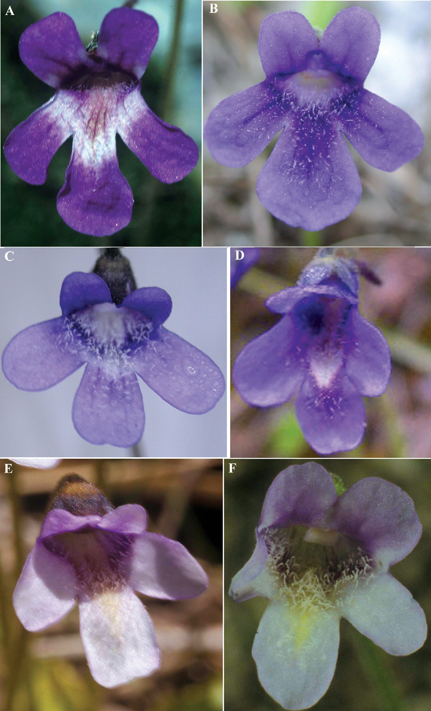
Fig. 1. Front views of ﬂow- ers. — A: P. vallis-regiae (VRE). — B: P. ﬁorii (FIO).
— C: P. vulgaris subsp.
vulgaris (VUL-AB). — D:
P. vulgaris subsp. anzal- onei (VUL-ANZ). — E: P. vulgaris subsp. vestina (VUL-VES). — F: P. vul- garis subsp. ernica (VUL- ERN).

and FIO, VUL-AB and VUL-ANZ, VUL-VES
and VUL-ERN respectively (Fig. 5).

Seed morphology, anatomy and morphometry

General seed morphology revealed some inter-
esting variation patterns. VRE, FIO and P. vul- garis s. lato (including the VUL-ALP accession from the Alps) all show comparable seed length and width but VUL-ERN, which has seeds that clearly tend to be longer (Fig. 6A) and thin- ner (Fig. 6B) than others, resulting in a spindly (instead of elliptic) shape. Also the covariance (here showed as ratio) among micropylar seed

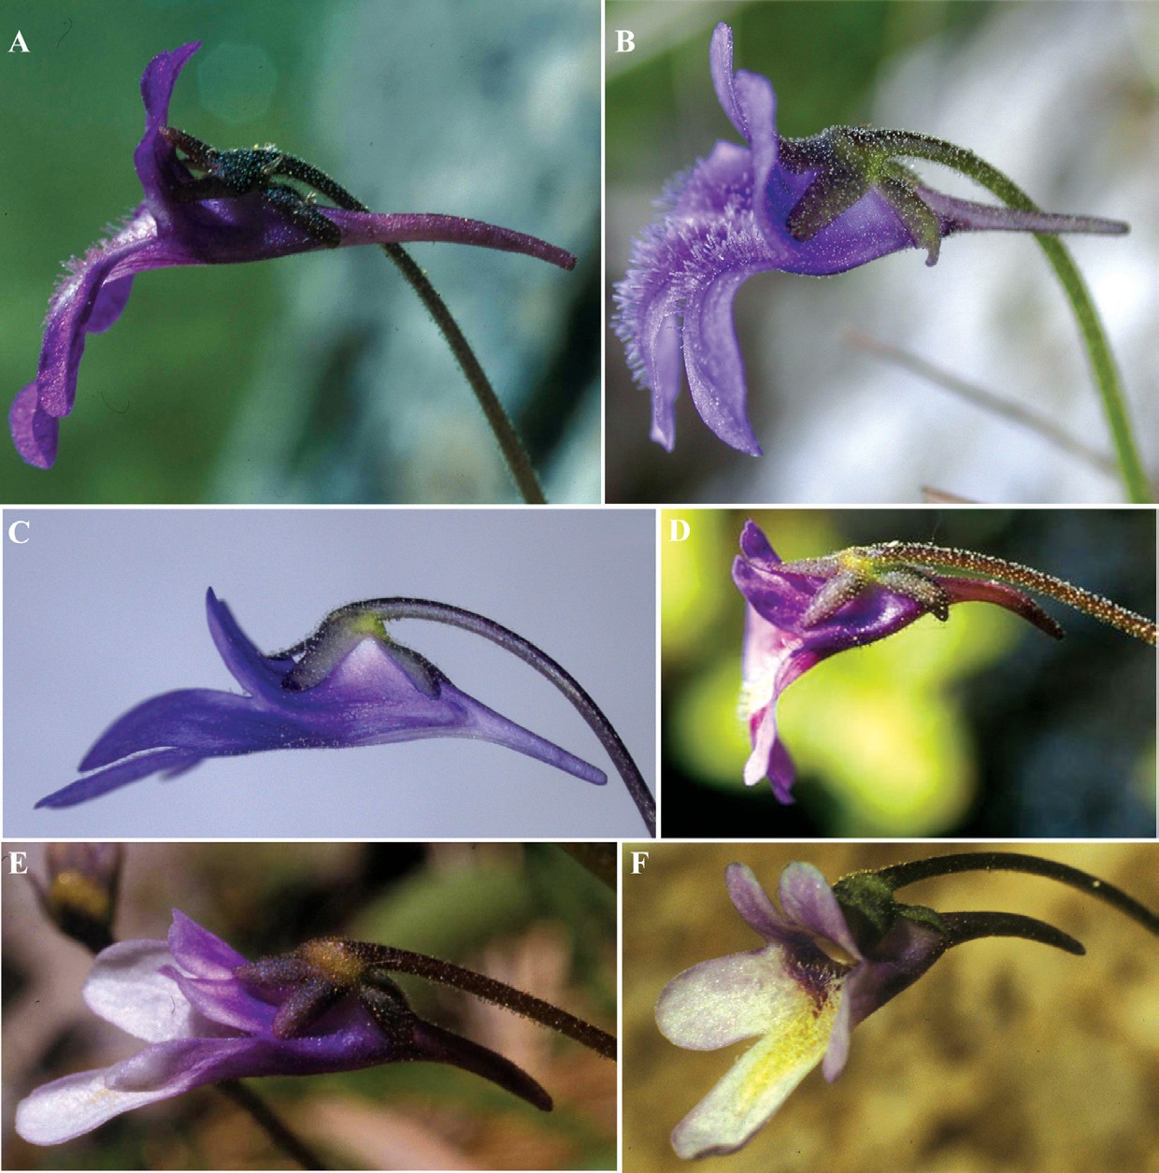
Fig. 2. Lateral views of ﬂowers. — A: P. vallis- regiae (VRE). — B: P. ﬁorii (FIO). — C: P. vulgaris subsp. vulgaris (VUL-AB).
- D: P. vulgaris subsp.
anzalonei (VUL-ANZ).
- E: P. vulgaris subsp.
vestina (VUL-VES). — F:
P. vulgaris subsp. ernica
(VUL-ERN).

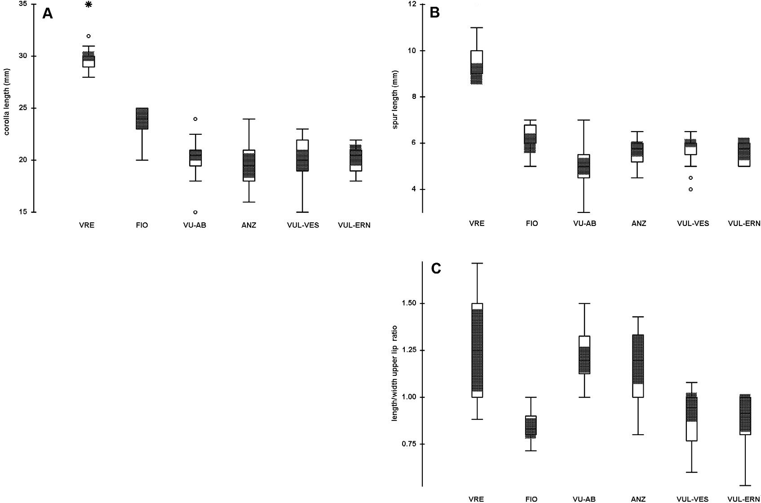
Fig. 3. Boxplots illustrating the variability of (A) corolla length (mm), (B) spur length (mm), and (C) length/width ratio of the upper lip lobes, in the studied populations. The outlined central box depicts the middle 50% of the data extending from upper to lower quartile; the hori- zontal bar indicates the median. The ends of the whisk- ers indicate the minimum and maximum values, unless outliers are present in which case the whiskers extend to a maximum of 1.5 times the inter-quartile range. Superimposed grey areas indicate conﬁdence interval bounds around its median (median ± 1.58 times the inter-quartile range). Circles indicate outliers, unless extreme outliers are present in which case the circles extend to a maximum of 3 times the inter-quartile range and the extreme outliers are indicated as asterisks.

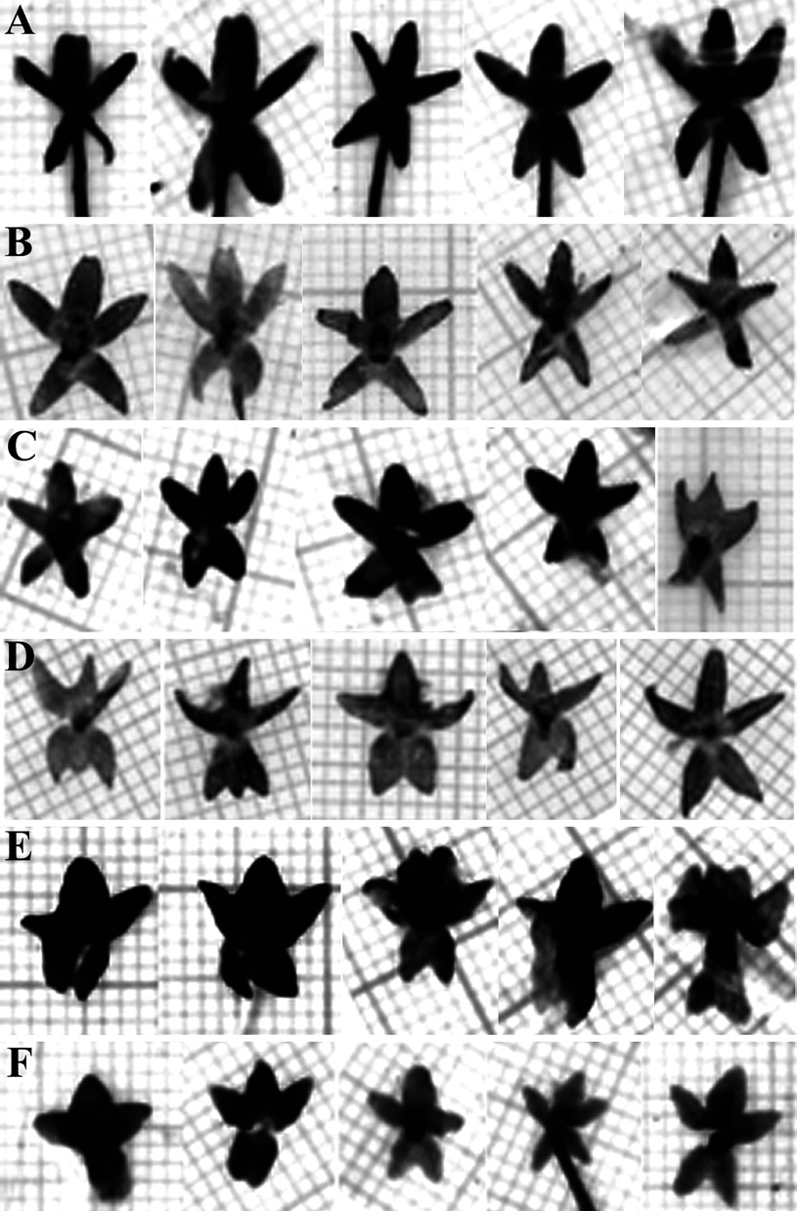

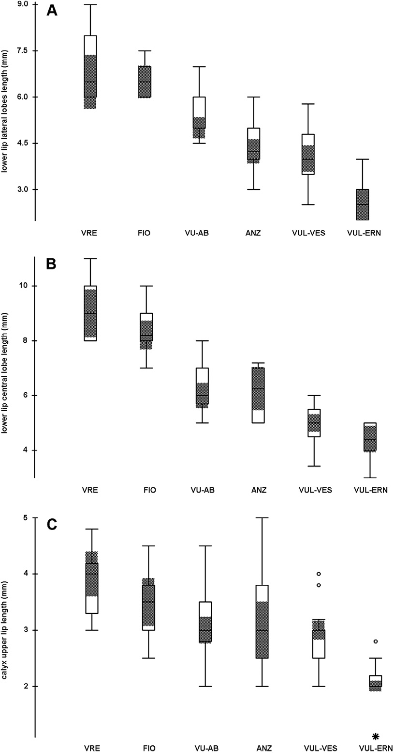
Fig. 4. Boxplots illustrating the variability of (A) length of lower lip of the corolla lateral (mm), (B) central lobe length (mm), and (C) calyx upper lip length (mm) in the studied populations (for more explanations see caption to Fig. 3).

appendage and seed lengths shows the same trend, although less markedly (Fig. 6C).
SEM analysis (Fig. 7) of seeds also showed that all units share rounded-polygonal exotesta cells, divided more or less evidently by a furrow. The size (length and width) of exotesta cells is approximately similar in all units, but tends to be bigger in VUL-ERN. In the latter unit, the anticlinal walls of exotesta cells are also deeper than in other units (Fig. 7H), while in VRE they are markedly the least evident ones (Fig. 7B). The latter unit (Fig. 7A) and VUL-ERN (Fig. 7G) have both > 200 exotesta cells, while the
Fig. 5. Variability in calyx. — A: P. vallis-regiae (VRE).
- B: P. ﬁorii (FIO). — C: P. vulgaris subsp. vulgaris (VUL-AB). — D: P. vulgaris subsp. anzalonei (VUL- ANZ). — E: P. vulgaris subsp. vestina (VUL-VES).
- F: P. vulgaris subsp. ernica (VUL-ERN). Calyces are mounted on millimeter paper.

other units all have < 200 (Figs. 7C–7E). Finally, only in VRE a light chalazal end appendage was noted (Fig. 7A). VUL-ANZ and VUL-VES seeds are not shown, but they are nearly identical to those of VUL-AB (Fig. 7E).
All units have only one plicate cotyledon. Cotyledon in VRE, VUL-ALP, VUL-VES and VUL-ANZ is asymmetric in cross section, while in VUL-AB and VUL-ERN it is almost symmet- ric. In FIO the cotyledon was symmetric.

Discussion
By comparing our results with the data known for similar species, it becomes clear that VRE
- formerly quoted as “P. reichenbachiana” (i.e. by Tammaro & Fiori 1987), but already noted to

be different from it by Steiger (1998) and Casper and Steiger (2001) — has indeed several differ- ent characters from the “true” P. reichenbachiana (Schindler 1906, Casper 1966). They include the (likely) homophyllous rosette and the very dif- ferent colouring pattern of corolla. On the other hand, the colouring pattern is nearly identical to that of the recently described homophyllous P. poldinii (Casper & Steiger 2001), from which VRE is well distinguished by the bigger size of scape and leaves and by the capsule shape (Table 2). The presence of a seed chalazal end appendage — nearly identical to that observed by us in VRE — was known, within sect. Pin- guicula, only for P. reichenbachiana (Degtjareva et al. 2004). Unfortunately, there is no detailed information available on the seed structure of P. poldinii. The latter species, due to its putatively taxonomic isolation, was regarded by Casper and Steiger (2001) as possibly belonging to the informal series “Prealpicae”. In our opinion,
P. reichenbachiana, P. poldinii and VRE are all closely related from taxonomic (and perhaps also phylogenetic) point of view, but any taxonomic recognition at supraspeciﬁc level is premature. Nonetheless, it is worth noting that in the recent phylogenetic study by Cieslak et al. (2005) P. reichenbachiana, P. poldinii (and P. leptoceras) were considered sister to all other studied spe- cies of Pinguicula sect. Pinguicula (including P. ﬁorii and P. vulgaris). The bootstrap support was high (96% to 100%, depending on the algorithm used).
FIO — described as P. ﬁorii (Tammaro & Pace 1987) — has also several unique traits, which allow us to distinguish it from the other units discussed above, such as the shape, size and colouring pattern of the corolla, and the sym- metric cotyledon cross section. The latter feature is instead shared with P. leptoceras (Degtjareva et al. 2004), but this species has very different corolla features (Casper 1966, see Table 2).
According to Casper (1966), central Italy is one of the southernmost areas where P. vul- garis occurs and it is isolated from the main distribution range of the species. In particular VUL-AB occurs in northern Abruzzo (M.ti della Laga), and its morphological features are widely overlapping with those reported for P. vulgaris from the Alps and other European localities by

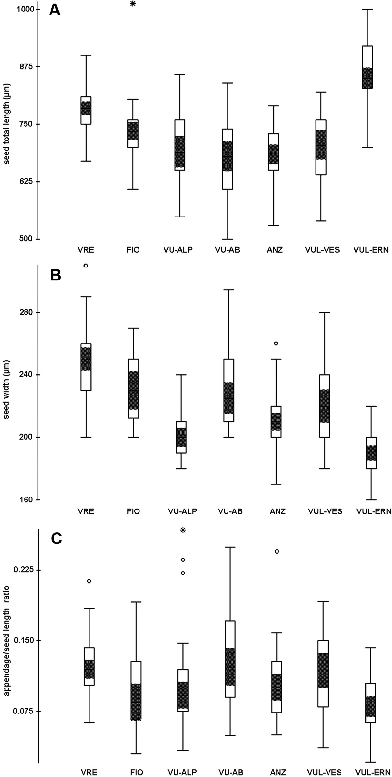
Fig. 6. Boxplots illustrating the variability of (A) seed total length (µm), (B) width (µm), and (C) mycropylar seed appendage/seed length ratio in the studied popu- lations (for more explanations see caption to Fig. 3).

several authors (Casper 1966, Romo et al. 1996, Blanca et al. 1999, Blanca 2001, Degtjareva et al. 2004, Heslop-Harrison 2004, L. Legendre &
T. Cieslak, unpubl. data; see Table 3). Each of the remaining three systematic units circumscribed by us within the species have instead peculiar corolla and calyx features associated with sten- oendemic distribution: VUL-VES occurring in central Abruzzo (Gran Sasso and Altopiano delle Rocche), and VUL-ANZ and VUL-ERN occur- ring instead in western central Abruzzo (Ernici) and CE Latium (Simbruini), respectively. All

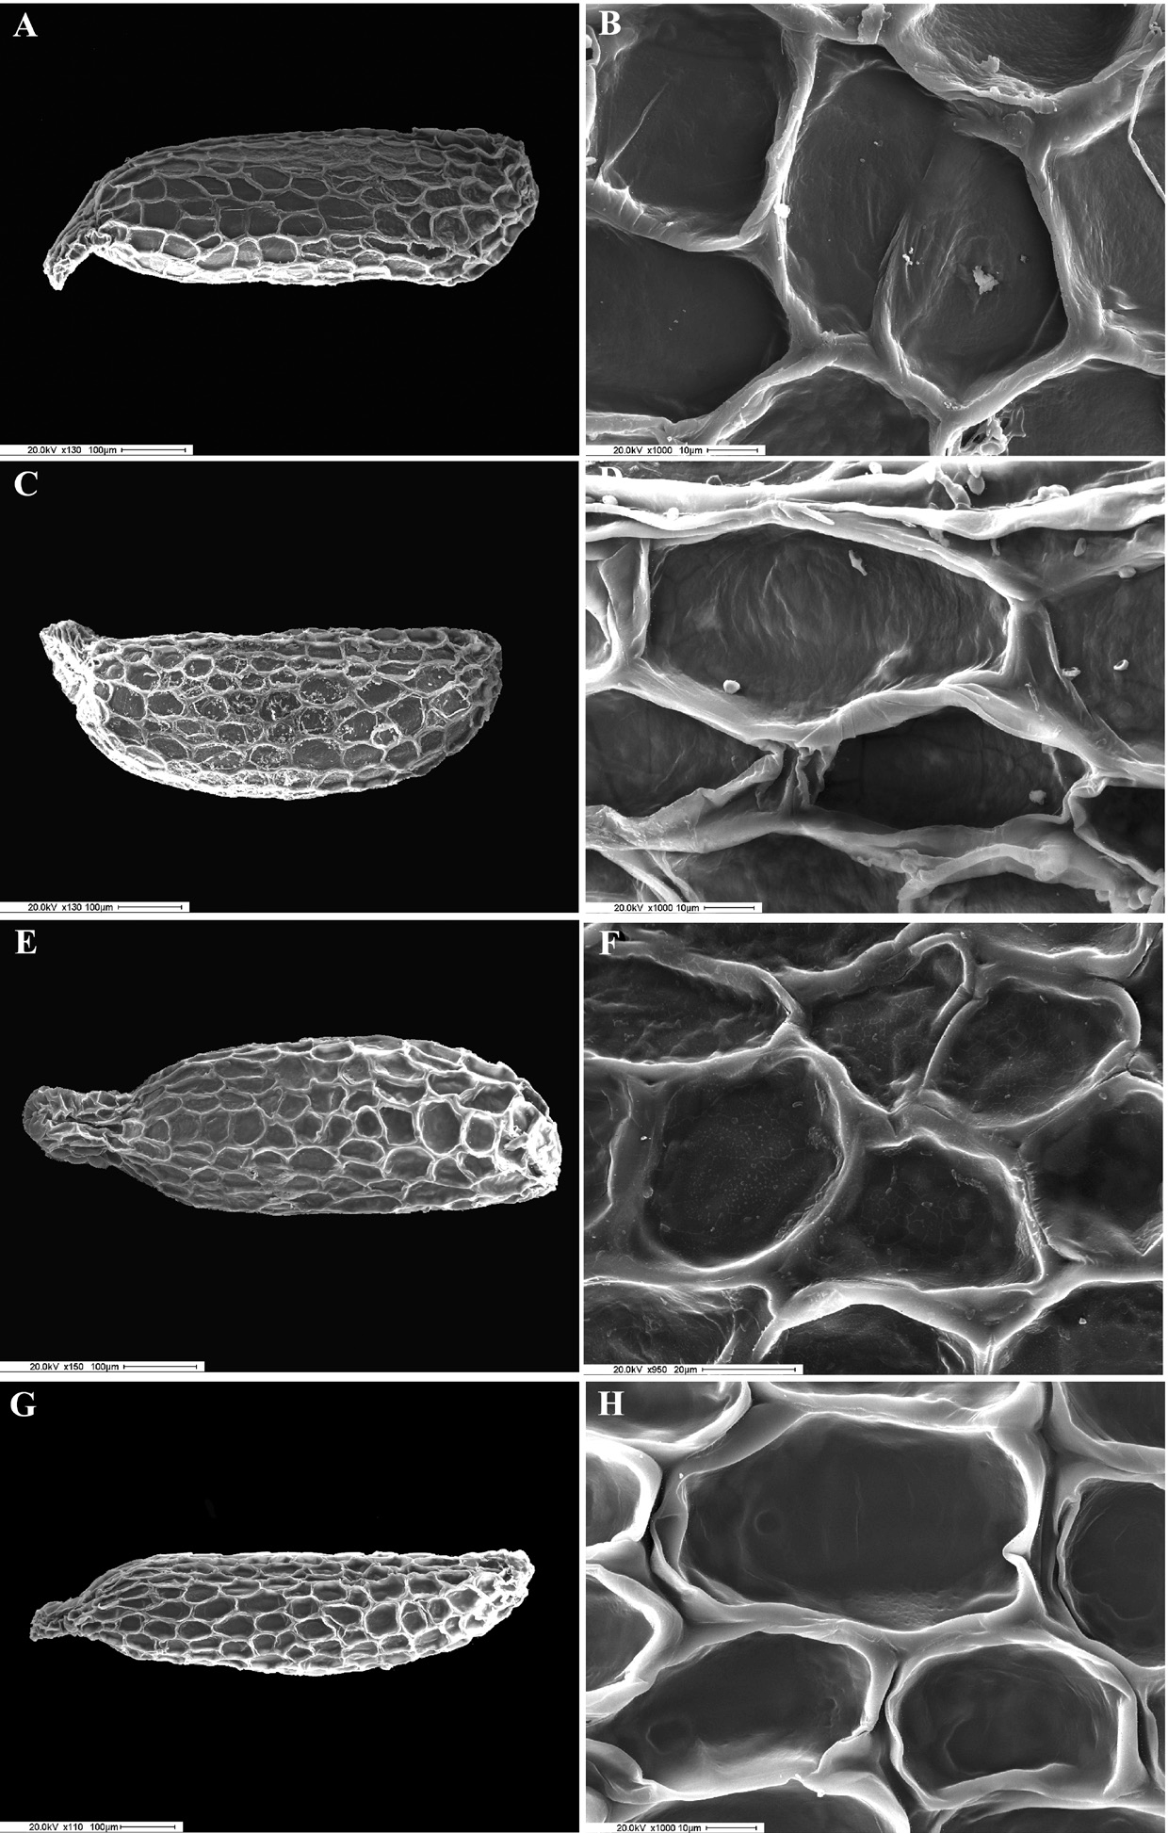
Fig. 7. SEM microphoto- graphs of seeds (general view and details of exot- esta cells). — A and B: P. vallis-regiae (VRE). — C and D: P. ﬁorii (FIO). — E and F: P. vulgaris subsp. vulgaris (VUL-AB). — G and H: P. vulgaris subsp. ernica (VUL-ERN).

these units show low intra- and inter-popula- tional variability.
According to our results, and considering the allopatric occurrence of all the studied units (Fig. 8) in central Italy, we treat VRE and FIO as belonging to two clearly distinct species, in the light of their peculiar and unique features. VRE needs to be described as new to science, since it cannot be placed in any known taxon; while for
FIO the validly published name P. ﬁorii is avail- able.
As for the other systematic units (P. vulgaris
s. lato), VUL-AB can be doubtlessly identiﬁed with P. vulgaris s. stricto, while for the remain- ing three — all clearly belonging to the latter taxon but showing a distinctive combination of characters related to geographic isolation — we think that taxonomic recognition at the subspe-

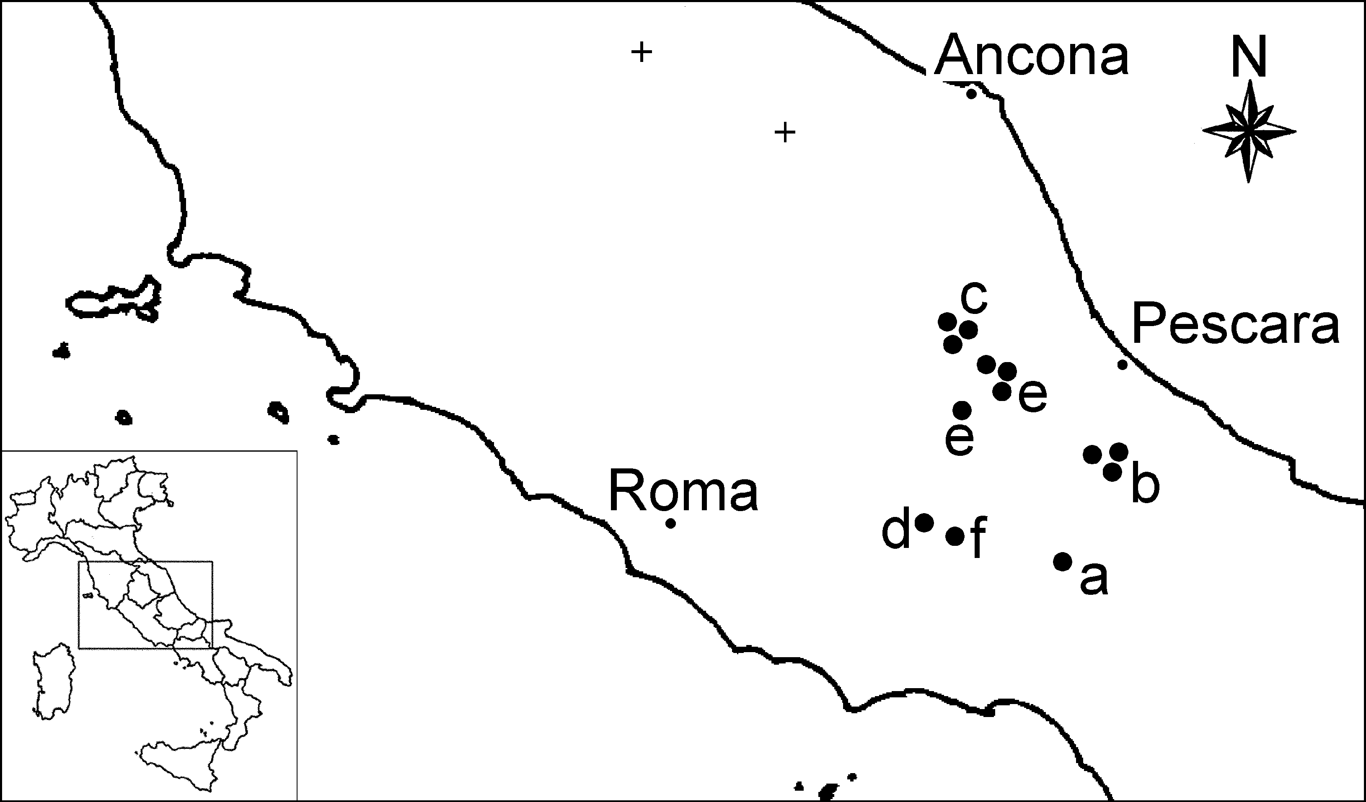

Fig. 8. Distribution of Pinguicula in central Italy: (a) P. vallis-regiae (VRE); (b) P. ﬁorii (FIO); (c) P. vulgaris subsp. vulgaris (VUL-AB); (d) P. vulgaris subsp. anzal- onei (VUL-ANZ); (e) P. vulgaris subsp. vestina (VUL- VES); (f) P. vulgaris subsp. ernica (VUL-ERN,). “+” indicates two extinct localities from Marche, likely to be referred to P. vulgaris subsp. vulgaris.

cies rank is appropriate. In our opinion, none of them can be placed in previously described taxa, and they are therefore here described as new to science.
All the studied populations grow in very rare and fragile habitats and deserve protection, in particular VRE (here described as P. vallis- regiae), VUL-ERN (here described as P. vulgaris subsp. ernica) and VUL-ANZ (here described as
P. vulgaris subsp. anzalonei) occur all in single localities and would deserve special conserva- tional attention. Uncontrolled collection of these “carnivorous” plants by amateurs can be particu- larly dangerous. We suggest the insertion of all these taxa in the Red Book of Italian Plants.

Taxonomic treatment
Pinguicula vallis-regiae F. Conti & Peruzzi, sp. nova (Figs. 1A, 2A, 5A, 9)

Pinguicula reichenbachiana auct., Fl. Ital. p.p.

Planta (75)84–156(170) mm alta. Rosula verosimiliter homophylla; folia (30)34.5–61.7(72) mm longa. Corolla late ampliata (120°–180° angulo aperturae), viola, centro albo, striis lon- gitudinalibus violaceis notatis, 28–31.8(35) mm longa; lobi labii inferi oblongi, non rotundati, inter se non tegenti; calcar 9–11(12) mm longum. Labium superum calycis valde tripartitum; lobi labii superi elliptico-lineari. Capsula ovoidea.

Fig. 9. General view of Pinguicula vallis-regiae from Camosciara (Abruzzo).

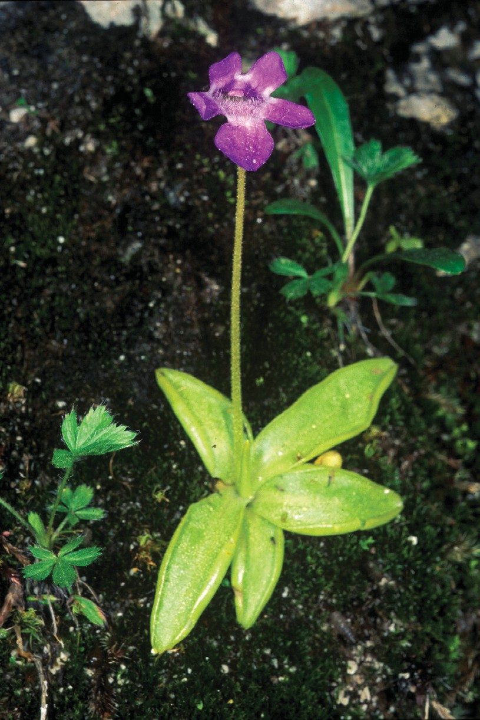
HOLOTYPE: Italy. Abruzzo, Abruzzo National Park, Camosciara, Villetta Barrea (L’Aquila), rupi stillicidiose, 1073 m a.s.l., 41°45.925´N, 13°54.535´E, 26.V.1994 F. Conti (APP).

Herb perennial, small, rosette-forming, scapose, succulent. Stem short, with ascending, not branching rhizome and numerous adventi- tious ﬁbrous roots. Rosettes to 60–150 mm in diameter with few, 5–9 leaves lying more or less ﬂat on ground, likely homophyllous. Overwinter- ing as buds (hibernacula). Leaves in outline obo- vate-oblong, obtuse at apex, narrowed at base, 3– 4 ¥ as long as broad, (30)34.5–61.7(72) mm long, 10.9–18 mm broad, margin entire, sometimes slightly incurved, brittle, upper surface densely covered with mucilaginous sessile and stalked glands. Scapes 1–2, erect, (75)84–156(170) mm tall, terete, 1-ﬂowered, directly beneath ﬂower densely covered with stipitate glands, to base sparsely glandular. Flowers relatively large, 28–31.8(35) mm long (spur included). Calyx distinctly bilabiate, densely covered on both sur-

Table 2. Comparison of Pinguicula ﬁorii (data from Tammaro & Pace 1987, Degtjareva et al. 2004, our personal observations), P. vallis-regiae (data from our personal observations), P. reichenbachiana (data from Schindler 1906, Casper 1966, Degtjareva et al. 2004), P. poldinii (data from Casper & Steiger 2001) and P. leptoceras (Casper 1966, Degtjareva et al. 2004). Quantitative data are expressed in 10–90 percentiles, with extreme values in brackets.
330
Conti & Peruzzi • ANN. BOT. FENNICI Vol. 43

 | P. ﬁorii | P. vallis-regiae | P. reichenbachiana | P. poldinii | P. leptoceras
Growth type | temperate | temperate | temperate | temperate | temperate
Rosette type | homophyllous | homophyllous(?) | heterophyllous | homophyllous | homophyllous
Leaf
number | 7–8 | 5–9 | 5–11 | (4)5–6(8) | 5–8
shape | obovate-oblong | obovate-oblong | ovate-oblong | obovate-oblong | ovate-oblong
 |  | to lanceolate | to lanceolate
length (mm) | (20)24–36 | (30)34.5–61.7(72) | (25)40–70(115) | (22)25–35(39) | (19)25–40(65)
width (mm) | (9)11–14(16) | (10.9)12–16.7(18) | (5)9–12(19) | (5)7–10(13) | (6)10–16(22)
Scape size (mm) | 50–76 | (75)84–156(170) | 60–80 | (32)45–70(78) | (13)40–100(133)
Calyx
upper lobe shape | ovate, the central one | elliptic-linear, | linear, | ovate-oblong, | triangular, acute
 | sometimes slightly | the central one | the central one | the central one | at apex
 | biﬁd | often biﬁd | often biﬁd | often biﬁd or
 |  |  |  | multiﬁd
upper lobe size (mm) | 2.5–4.5 | 3–4.8 | ca. 6 | 4–5 | ca. 5
bottom lobe shape | divergent, united | divergent, united | lanceolate | united | narrowly
 | for 1/3 | for 1/3-1/2 |  | for 1/6-1/2 | lanceolate
bottom lobe size (mm) | 2.5–4 | 3.2–4.8 | ca. 6 | 4–5 | ca. 5
Spur  length (mm) | (4.5)5–7 | 9–11(12) | (5)8–11(15) | (7)9–11(13) | (1)4–6(9)
shape | straight | slightly curved | slightly curved | slightly curved | straight
 |  | downwards | downwards | downwards
Corolla
length, spur included (mm) | (19.5)20–25(25.5) | 28–31.8(35) | (16)24–34(44) | (21)24–28(32) | (10)16–25(31)
colour | blue-violet | violet, white at | violet with three | violet, white | blue-violet with
 |  | the centre | white dots | at the centre | three white dots
 |  | with violet stripes |  | with violet stripes
lower lip lobes | close but not | not overlapping | close but | not overlapping | overlapping
 | overlapping |  | not overlapping
throat | white | white | white | white | white
opening angle | 90–120° | 120–180° | 90–120° | 120–180° | 45–90°
upper lobe length (mm) | 3.2–5 | 4.6–6 | ? | 5-7 | ?
upper lobe width (mm) | 3.9–6 | (3)3.5–5(6.8) | ? | ? | ?
lateral lobe length (mm) | 6–7.5 | 6–8(9) | ? | ? | ?
lateral lobe width (mm) | 4–5.5 | (3.5)4–5.7(8) | ? | ? | ?

median lobe length (mm) | 7–10 | 8–10(11) | ? | 9–11 | ?
median lobe width (mm) | 5.2–8 | (5)6–8.3 | ? | 5–7 | ?
Capsule  length (mm) | ? | 4.5–5 | ? | 5 | 7–8
shape | ovoid | ovoid | ovoid to | globose | ovoid
 |  |  | subglobose
Cotyledon
number | 1 | 1 | 1 | ? | 1
symmetry | symmetric | asymmetric | asymmetric | ? | symmetric
aestivation | plicate | plicate | plicate | ? | plicate
Outer parts of anticlinal walls
of adjacent exotesta cells | divided by a furrow | divided by a furrow | divided by a furrow | ? | divided by a furrow
Exotesta cells  shape | rounded-polygonal | rounded-polygonal | rounded-polygonal | rounded-polygonal | rounded-polygonal
number | < 200 | > 200 | > 200 | ? | < 200
length (µm) | (25)36–86(89) | (47)50–85(89) | 42–79 | ? | 30–93(120)
width (µm) | (18.7)29–45(47) | (25)30–48(53) | 21.4–43.5(50) | ? | (15)21.7–45
Depth of anticlinal walls of exotesta cells (µm) | (40.1)40.4–80(80.3) | 20.4–50.6 | ? | ? | (20)21.5–37.9(45)
Chalazal seed appendage | no | yes | yes | ? | no
Micropylar seed appendage/seed length ratio | (0.02)0.05–0.13(0.16) | (0.06)0.08–0.15(0.21) | 0.16 | ? | 0.10
Seed
shape | elliptic | elliptic | elliptic | elliptic | elliptic
length, appendage included (µm) | (610)642–791(850) | (670)703–841(900) | 850–1000 | 600–700(800) | 700–885
width (µm) | (200)210–258(270) | 210–274(310) | 200–400 | 300–400 | 200–300
ANN. BOT. FENNICI Vol. 43 • Pinguicula in central Italy
331

Table 3. Comparison within Pinguicula vulgaris. Data for from the Alps and extra-Italian localities derive from works of Casper (1966), Romo et al. (1996), Blanca et al. (1999), Blanca (2001), Heslop-Harrison (2004) for general morphology; Degtjareva et al. (2004), L. Legendre & T. Cieslak (unpubl. data) and our personal observations for details of seed morphology. Quantitative data are expressed in 10–90 percentiles, with extreme values in brackets.
332
Conti & Peruzzi • ANN. BOT. FENNICI Vol. 43

 | P. vulgaris including the Alps and  other extra-Italian provenances | P. vulgaris subsp. vulgaris (Abruzzo) | P. vulgaris subsp. anzalonei (Latium) | P. vulgaris subsp. ernica (Abruzzo) | P. vulgaris subsp. vestina (Abruzzo)
Growth type | temperate | temperate | temperate | temperate | temperate
Rosette type | homophyllous | homophyllous | homophyllous | homophyllous | homophyllous
Leaf
number | 5–11 | 5 | 5–6 | 5–6 | 6–7
shape | ovate to | obovate-oblong | obovate-oblong | obovate-oblong | obovate-oblong
 | oblong-lanceolate
length (mm) | (10)20–50(90) | (39)41–66(75) | (10)13.7–31.6(34) | 33–51(55) | (21)25.8–56.8(58)
width (mm) | (7)10–20(27) | (16)18–23(24) | (4)7.6–12 | (8)10.7–18.1(19) | (13)14.2–22.8(24)
Scape size (mm) | (25)75–180(272) | ? | ? | (127)131–175(180) | ?
Calyx
upper lobe shape | united for 1/2, | united for 1/3, | united for 1/3, | united for 1/2, | united for 1/2,
 | triangular-ovate | triangular-ovate | triangular-ovate | triangular | triangular; the central
 | to elliptic |  |  |  | one often biﬁd
upper lobe size (mm) | 2.5–3 | 2–4.5 | 3–5 | 1.1–2.8 | 2–3.8
bottom lobe shape | united for 1/2–2/3 | united for 1/2 or more, | united for more than | united more than 1/2 | united for 2/3 or more,
 |  | ovate | 1/2, ovate | (often completely), | ovate
 |  |  | often with a third | ovate
 |  |  | central lobe
bottom lobes size (mm) | 1.5–4.5 | 1.8–3.5 | 2.5–4.5 | 1.5–2.7 | 2–4
Spur  length (mm) | (1)3–6(10) | 3.5–7 | 4.5–6.5 | 5–6 | 4.5–6.5
shape | straight to slightly | straight | slightly curved | slightly curved | slightly curved
 | curved downwards | downwards | downwards | downwards
Corolla
length, spur included (mm) | (9)15–22(32) | 15–22.5 | 16–24 | 18–22 | 15–23
colour | blue-violet | blue-violet, with | blue-violet, with | pale violet, | pale violet,
 |  | white hairs/dot | few white hairs | whitish-rose the | whitish-rose
 |  | near the throat | a white V-shaped | lower lip, with | the lower lip, with
 |  |  | dot on median | white hairs; | white hairs;
 |  |  | lower lip, surrounded | a yellow stripe | a yellowish
 |  |  | with deep | on median | stripe on median
 |  |  | violet | lower lip | lower lip

lower lip lobes | not overlapping | not overlapping | close, but not | not overlapping | not overlapping
 |  |  | overlapping
throat | white | white | white | yellowish | white-yellowish
opening angle | 30°–80°(120°) | 30°–80° | 90°–120° | 70°–90° | 30°–80°
upper lobe length (mm) | 2.2–6 | 3–6 | 2–5 | 2–4 | 2.2–4
upper lobe width (mm) | 2.2–5.2 | 3–4.5 | 2.2–3.5 | 2.5–5 | 2.5–5.2
lateral lobe length (mm) | 2–6.8 | 4.5–6.8 | 3–6 | 2–4 | 2.5–5.8
lateral lobe width (mm) | 2.3-5.2 | 3–5 | 3–5 | 2.3–3.8 | 2.5–5.2
median lobe length (mm) | 5–7.5 | 5–8 | 5–7.2 | 3–5 | 3.4–5.8
median lobe width (mm) | 2.4–6.5 | 3.1–5.5 | 3.5–6.5 | 2.9–4.5 | 2.4–6
Capsule  length (mm) | 4-6(10) | ? | ? | 4–5 | ?
shape | ovoid to globose | ? | ? | ovoid | ?
Cotyledon
number | 1 | 1 | 1 | 1 | 1
symmetry | ± asymmetric | slightly asymmetric | asymmetric | slightly asymmetric | asymmetric
aestivation | plicate | plicate | plicate | plicate | plicate
Outer parts of anticlinal walls
of adjacent exotesta cells | divided by a furrow | divided by a furrow | divided by a furrow | divided by a furrow | divided by a furrow
Exotesta cells  shape | rounded-polygonal | rounded-polygonal | rounded-polygonal | rounded-polygonal | rounded-polygonal
number | < 200 (> 200) | < 200 | < 200 | > 200 | < 200
length (µm) | (23)36–81(103) | (40)45–78(81) | (38)42–75(80) | (44)54–97(103) | (39)40–76(85)
width (µm) | (17)18–40(75) | (24)26–38(45) | (22)27–39(45) | (21)23–71(75) | (24)23–35(44)
Depth of anticlinal walls
of exotesta cells (µm) | (20)23–81(150.9) | 30.6–80.5(80.8) | (31)35–71(79) | (50.5)60.1–140.9(150.9) | (29)30–79.5(82)
Chalazal seed appendage | no | no | no | no | no
Micropylar seed appendage/
seed length ratio | (0.02)0.05–0.19(0.26) | (0.05)0.08–0.2(0.25) | (0.04)0.06–0.13(0.24) | (0.02)0.05–0.12(0.14) | (0.03)0.07–0.17(0.23)
Seed  shape | elliptic (spindly) | elliptic | elliptic | spindly | elliptic
length, appendage included (µm) | (500)680–816(1000) | (520)540–763(840) | (550)615–765(790) | (700)800–964(1000) | (540)580–805(820)
width (µm) | (160)200–280(320) | 200–261(270) | (170)180–240(260) | 170–210 | (180)190–255(280)
ANN. BOT. FENNICI Vol. 43 • Pinguicula in central Italy
333

faces and margins with stipitate glands, 6–10 in total diameter, upper lip divided nearly to base into 3 lobes elliptic-linear, central one often biﬁd; lower lip divided to 1/2 into 2 short lobes. Throat relatively densely covered with white clavate hairs. Spur slightly curved downwards, thin, 9–11(12) mm long. Corolla distinctly bila- biate, violet, white at centre with violet stripes, at throat white, spur violet, upper lip with 2 nearly identical lobes, 0.9–1.3 ¥ as long as broad, 4.6–6 mm long, erect, apex subtruncate to rounded; lower lip much larger than upper lip, with 3 lobes not overlapping, middle lobe distinctly longer and broader than lateral lobes, apex rounded to slightly truncate, front part of lobes bending downwards; whole corolla appears wide open (opening angle 120°–180°). Capsule ovoid, 4.5–5 mm in diameter, 1-loculate. Seeds minute, like sawdust, with reticulate surface, elliptic, (670)703–841(900) µm long, 210–274(310) µm
wide. Micropylar seed appendage/seed length ratio (0.06)0.08–0.15(0.21). Number of exotesta cells > 200, exotesta cells (47)50–85(89) µm long, (25)30–48(53) µm wide, depth of anticli- nal walls of exotesta cells 20.4–50.6 µm, outer parts of anticlinal walls of adjacent exotesta cells divided by a furrow, presence of a light chalazal seed appendage. Cotyledon 1, plicate, hardly asymmetric in cross section. Flowering May, fruiting May–June.

ETYMOLOGY: The name of this species comes from “Vallis Regia”, old medieval name of high Sangro Valley, from which also the name “Barrea” stems.

DISTRIBUTION: Endemic to Camosciara (south- ern Abruzzo; Fig. 8).
HABITAT ECOLOGY: Dripping calcareous cliffs.

Pinguicula ﬁorii Tammaro & Pace (Figs. 1B, 2B, 5B)

Inform. Bot. Ital. 19: 430. 1987.
HOLOTYPE: Italy. Abruzzo, Versante orientale della Majella, in località Cannelluccia di Bocca di Valle in una forra, su rupi calcaree muschiose soggette a stillicidio, 750 m, 30.V.1983 Tammaro (AQUI!; isotypes FI!, RO!).
ILLUSTRATIONS: Tammaro & Pace (1987: 433, fig 2);
ETYMOLOGY: This species was dedicated by Tammaro and Pace (1987) to Prof. Adriano Fiori (1865–1950), an emi- nent Italian botanist.
DISTRIBUTION: Stenoendemic to few localities in Majella Massif (eastern Abruzzo; Fig. 8).
HABITAT ECOLOGY: Dripping calcareous cliffs from 750 to 2046 m a.s.l.

Pinguicula vulgaris L.

Sp. Pl.: 17. 1753. (“Habitat in Europae uliginosis”).
LECTOTYPE (designated by Casper 1966): Herb. Linn. No.
33.1 (LINN, microﬁche!).

subsp. vulgaris

DISTRIBUTION: Circumboreal (Casper 1966). In central Italy on Laga Mountains (Marche, Lazio, Abruzzo). A. S. B. Brilli-Cattarini (pers. comm.) found P. vulgaris — very likely subsp. vulgaris
- also in other localities in Marche: M. Car- pegna and M. Catria. However, in both latter localities the plant is presently extinct because of human activities (Fig. 8).
HABITAT ECOLOGY: Marshes, bogs, humid grasslands, from 300 to 2600 m a.s.l. (Heslop- Harrison 2004). In central Italy mainly on sili- ceous substrates.

subsp. anzalonei Peruzzi & F. Conti,
subsp. nova (Figs. 1D, 2D, 5D)

Corolla late ampliata (90°–120° angulo aperturae), violaceo-caerulea, lobus medius labii inferi macula alba, viola intense marginata V-forme notata; labium inferum lobis lateralibus 3–6 mm longum. Labium inferum calycis saepe trilobum.

HOLOTYPE: Italy. Latium, Simbruini, tra Subiaco e Jenne (Roma), loc. “Piscicarello di Jenne”, rupi stillicidi- ose di cappellaccio travertinoso, 495 m a.s.l., 41°53.912´N, 13°08.374´E, 26.V.2005 F. Conti, F. Bartolucci, A. Bernar- dini (APP; isotype APP).

Leaves in outline obovate-oblong, obtuse at apex, narrowed at base, 2–3 ¥ as long as broad, (10)13.7–31.6(34) mm long, (4)7.6–12 mm wide. Calyx distinctly bilabiate, densely covered on both surfaces and margins with stipitate glands, 6–10 mm in total diameter, upper lip divided for 1/2–2/3 into 3 triangular-ovate lobes, lower lip divided up to half of its own length, or less,

into 2(3) very short ovate lobes. Throat relatively densely covered with white clavate hairs. Spur slightly curved downwards, 4.5–6.5 mm long. Corolla distinctly bilabiate, blue violet, with few white hairs and a white V-shaped dot on median lower lobe, spur violet, upper lip with 2 nearly identical lobes, 1–1.5 ¥ as long as broad, 2–5 mm long, erect, apex rounded; lower lip much larger than upper lip, with 3 lobes (rarely 4) not over- lapping (lateral lobes 3–6 mm), apex rounded to slightly truncate; whole corolla appears with an opening angle 90°–120°. Seeds minute, like saw- dust, with reticulate surface, elliptic, (550)615– 765(790) µm long, (170)180–240(260) µm wide. Micropylar seed appendage/seed length ratio (0.04)0.06–0.13(0.24). Number of exotesta cells
< 200, exotesta cells (38)42–75(80) µm long, (22)27–39(45) µm wide; depth of anticlinal walls of exotesta cells (31)35–71(79) µm; outer parts of anticlinal walls of adjacent exotesta cells divided by a furrow; chalazal end appendage absent. Cotyledon 1, plicate, asymmetric in cross section. Flowering May, fruiting May–June.

ILLUSTRATIONS: Anzalone (1984: 197, “Pinguicula vul- garis L. (subsp. nova?)”.
ETYMOLOGY: This subspecies is dedicated to Prof. Bruno Anzalone (University of Rome “La Sapienza”) who ﬁrst hypothesized that this unit was differing in some way from P. vulgaris s. stricto (Anzalone 1983, 1984).

DISTRIBUTION: Known only from a single locality in Simbruini mountains (east Latium), where two main populations occur (Fig. 8).
HABITAT ECOLOGY: Dripping cliffs at low alti- tude.

subsp. vestina F. Conti & Peruzzi, subsp. nova (Figs. 1E, 2E, 5E)

Corolla pallide violacea, lobo medio labii inferi stria lutea notata, labium inferum roseo- album. Calyx 2–3.8 mm longus; lobus media- nus labii superi saepe bilobus. Semina elliptica (540)580–805(820) µm longa.

HOLOTYPE: Italy. Abruzzo, Gran Sasso, M. Prena, ver- sante settentrionale, Fossaceca, presso la Fonte del Peschio, 1400 m, 6.VI.05 F. Conti, A. Manzi (APP).

Calyx distinctly bilabiate, 4–8 mm in total
diameter, upper lip divided for 1/2 into 3 tri- angular-ovate lobes, central one often bilobe, lower lip divided up to 1/3 of its own length, or less, into 2 very short ovate lobes. Throat rela- tively densely covered with white clavate hairs. Spur slightly curved downwards, 4.5–6.5 mm long. Corolla distinctly bilabiate, pale violet, whitish-rose lower lip, with white hairs, a yel- lowish stripe on median lower lobe, spur violet, upper lip with 2 nearly identical lobes, 0.7–0.9 ¥ as long as broad, 2.2–4 mm long, erect, apex rounded, lower lip much larger than upper lip, with 3 lobes not overlapping (the median one 3.4–5.8 mm long), apex rounded; whole corolla appears with an opening angle 30°–80°. Seeds minute, like sawdust, with reticulate surface, elliptic, (540)580–805(820) µm long, (180)190– 255(280) µm wide. Micropylar seed append- age/seed length ratio (0.03)0.07–0.17(0.23). Number of exotesta cells < 200, exotesta cells (39)40–76(85) µm long, (24)23–35(44) µm
wide; depth of anticlinal walls of exotesta cells (29)30–79.5(82) µm; outer parts of anticlinal walls of adjacent exotesta cells divided by a furrow. Chalazal end appendage absent. Coty- ledon 1, plicate, asymmetric in cross section. Flowering June–July, fruiting July–August.

ETYMOLOGY: The name comes from the ancient Italian people called Vestini that lived in the Gran Sasso area.

DISTRIBUTION: Endemic to Gran Sasso Massif, where it grows in several localities: M. Prena, Pietracamela, between Vado di Corno and Valle dell’Inferno, Corno Piccolo and Altopiano delle Rocche in loc. Campo di Rovere (Fig. 8).
HABITAT ECOLOGY: Marshes, bogs, humid grasslands on calcareous substrate.

subsp. ernica Peruzzi & F. Conti, subsp. nova (Figs. 1F, 2F, 5F)

Differt a P. vulgare subsp. vestina: calyce minore longitudine (1.1–2.8 mm); labio infero calycis saepe unilobo; semina fusiformia majore amplitudine (700)800–964(1000) ¥ 170–210 µm.

HOLOTYPE: Italy. Abruzzo, Ernici, sottogruppo dei M.ti Cantari, Riserva Naturale Zompo Lo Schioppo, Morino (L’Aquila), rupi stillicidiose ai piedi della cascata, 730 m

a.s.l., 41°50.928´N 13°24.070´E, 4.VII.2004 F. Conti, F. Bar-
tolucci, M. Iocchi (APP).

Calyx distinctly bilabiate, 2–5 mm in total diameter, upper lip divided for 1/2 into 3 trian- gular-ovate lobes, lower lip divided up to half of its own length, or less (often not divided), into 2 very short ovate lobes. Throat relatively densely covered with white clavate hairs. Spur slightly curved downwards, 5–6 mm long. Corolla dis- tinctly bilabiate, pale violet, whitish-rose lower lip, with white hairs, a yellow stripe on median lower lobe, spur violet; upper lip with 2 nearly identical lobes, 0.7–1 ¥ as long as broad, 2–4 mm long, erect, apex rounded; lower lip much larger than upper lip, with 3 lobes not overlapping (the median one 3–5 mm long), apex rounded; whole corolla appears with an opening angle 70°–90°. Seeds minute, like sawdust, with reticulate sur- face, spindly, (700)800–964(1000) µm long, 170–210 µm wide. Micropylar seed appendage/ seed length ratio (0.02)0.05–0.12(0.14). Number of exotesta cells > 200, exotesta cells (44)54– 97(103) µm long, (21)23–71(75) µm wide; depth of anticlinal walls of exotesta cells (50.5)60.1– 140.9(150.9) µm; outer parts of anticlinal walls of adjacent exotesta cells divided by a furrow. Chalazal end appendage absent. Cotyledon 1, plicate, almost symmetric in cross section. Flow- ering June–July, fruiting July–August.

ETYMOLOGY: The name comes from Ernici mountains.

DISTRIBUTION: Stenoendemic, restricted to one locality (Zompo Lo Schioppo cascade) in Ernici mountains (western Abruzzo; Fig. 8).
HABITAT ECOLOGY: Dripping calcareous cliffs at ca. 700 m a.s.l.

Identiﬁcation key to Italian Pinguicula (corolla lengths include spur)

Note: According to Degtjareva et al. (2004), seed anatomy features in P. crystallina and P. hirtiﬂora are signiﬁcantly different, supporting the re-evaluation of two distinct species. For this reason we treat here the latter as a distinct species, despite its evident macromorphologi- cal afﬁnity with P. crystallina. In Peruzzi et
al. (2004) and Conti et al. (2005) this taxon appeared as P. crystallina subsp. hirtiﬂora.

1. Corolla (7)8–16(21) mm long, white, with a yellow dot on median lower lip P. alpina
- Corolla (9)15–32(44) mm long, whitish-rose to violet 2
- Corolla opening angle 30°–80° 4
- Corolla opening angle ≥ 90° (up to 180°) 3
- Corolla 20–25 mm long, uniformly blue-violet with white throat P. ﬁorii
- Corolla 16–32(44) mm long, colour-pattern not as above
...................................................................................... 7
- Corolla with three distinct white dots on lower lip; lobes of lower lip overlapping P. leptoceras
- Corolla without three distinct white dots on lower lip; lobes of lower lip not overlapping 5
- Corolla blue-violet, median lobe of lower lip 5–8 mm long, without a yellowish stripe ......................................
.............................................. P. vulgaris subsp. vulgaris
5. Corolla pale violet, median lobe of lower lip 3–5.8 mm long, with a yellowish stripe 6
6. Seeds spindly (700)800–964(1000) ¥ 170–210 µm, calyx upper lip 1.1–2.8 mm P. vulgaris subsp. ernica
6. Seeds elliptic (540)580–805(820) ¥ (180)190–255(280) µm, calyx upper lip 2–3.8 mm ........................................
................................................ P. vulgaris subsp. vestina
7. Corolla lobes of lower lip distinctly bilobe, rose and white, with yellow throat; overwintering as a rosette .....
...................................................................... P. hirtiﬂora
- Corolla lobes of lower lip entire, violet to blue-violet with white throat; overwintering as a bud (hibernacu- lum) 8
- Spur 4.5–6.5 mm, corolla 16–24 mm, blue-violet, with a white V-shaped dot, surrounded of deeper blue-violet on median lower lip P. vulgaris subsp. anzalonei
8. Spur (5)8–11(15) mm, corolla (16)24–34(44) mm, violet, with different colour pattern 9
- Corolla violet with three distinct white dots on lower lip, opening angle 90°–120°, plant heterophyllous (spring and summer leaves more or less differing) .....................
......................................................... P. reichenbachiana
- Corolla violet white at centre with violet stripes, open- ing angle 120°–180°, plant homophyllous (spring and summer leaves nearly identical) 10
- Leaves (22)25–35(39) mm long, scape size (32)45– 70(78) mm, capsule globose P. poldinii
10. Leaves (30)34.5–61.7(72) long, scape size (75)84– 156(170) mm, capsule ovoid P. vallis-regiae

Acknowledgements
We wish to thank Dr. Mariano Davoli (Department of Earth Sciences, University of Calabria) for electron microscope studies, Dr. Katia Francesca Caparelli (Natural history Museum of Calabria and Botanic Garden, University of Calabria) for seed sections, Dr. Dmitar Lakusic, Dr. Fabrizio Bartolucci, Dr. Daniela Tinti and Dr. Alessandra Bernardini for the useful help during the ﬁeld research.

References
Anzalone, B. 1983: Note di ﬂora romana: su alcune specie nuove o “ritrovate” nel Lazio. — Inform. Bot. Ital. 15: 13–17.
Anzalone, B. 1984: Prodromo della Flora Romana. — Regione Lazio, Roma.
Blanca, G. 2001: Pinguicula L. — In: Paiva J., Sales, F., Hedge, I. C., Aedo, C., Aldasoro, J. J., Castroviejo, S., Herrero, A. & Velayos, M. (eds.), Flora Iberica 14: 81–96. Real Jardín Botanico, CSIC, Madrid.
Blanca, G., Ruíz-Rejon, M. & Zamora R. 1999: Taxonomic revision of the genus Pinguicula L. in the Iberian penin- sula. — Folia Geobot. 34: 337–361.
Casper, S. J. 1966: Monographie der Gattung Pinguicula L.
— Biblioth. Bot. 127/128: 1–209.
Casper, S. J. 1972: Pinguicula L. — In: Tutin, T. G., Hey- wood, V. H., Burges, N. A., Moore, D. M., Valentine, D. H., Walters S. M. & Webb, D. A. (eds.), Flora Europaea 3: 294–296. Cambridge Univ. Press, Cambridge.
Casper, S. J. & Steiger, J. 2001: A new Pinguicula (Lentibu- lariaceae) from the pre-alpine region of northern Italy (Friuli-Venezia Giulia): Pinguicula poldinii Steiger et Casper spec. nov. — Wulfenia 8: 27–37.
Cieslak, T., Polepall, J. S., White, A., Müller, K., Borsch, T., Barthlott, W., Steiger, J., Marchant, A. & Legendre,
L. 2005: Phylogenetic analysis of Pinguicula (Len- tibulariaceae): chloroplast DNA sequences and morphol- ogy support several geographically distinct radiations.
— Amer. J. Bot. 92: 10: 1723–1736.
Conti, F. 1998: An annot[at]ed checklist of the ﬂora of the Abruzzo. — Bocconea 10: 1–276.
Conti, F., Abbate, G., Alessandrini, A. & Blasi, C. 2005: An annotated checklist of the italian vascular ﬂora. — Pal- ombi Ed., Roma.
Degtjareva, G., Casper, J., Hellwig, F. & Sokoloff, D. 2004: Seed morphology in the genus Pinguicula (Lentibu- lariaceae) and its relation to taxonomy and phylogeny.
— Bot. Jahrb. Syst. 125: 431–452.
Heslop-Harrison, Y. 2004: Biological ﬂora of the British Isles No. 237. Pinguicula L. — J. Ecol. 92: 1071–1118.
Jobson, R. W., Playford, J., Cameron, K. M. & Albert, V.
A. 2003: Molecular phylogenetics of Lentibulariaceae inferred from plastid rps16 intron and trnL-F DNA sequences: implications for character evolution and bio- geography. — Syst. Bot. 28: 157–171.
Legendre, L. 2000: The genus Pinguicula L. (Lentibular- iaceae): an overview. — Acta Bot. Gallica 147(1): 77–95. Peruzzi, L. 2004: Contribution to the cytotaxonomical knowl- edge of the genus Pinguicula L. (Lentibulariaceae): a synthesis of karyological data. — Carniv. Pl. Newslett.
33(4): 103–110.
Peruzzi, L., Passalacqua, N. G. & Cesca, G. 2004: Pingui- cula crystallina Sibth. et Smith subsp. hirtiﬂora (Ten.) Strid (Lentibulariaceae) in Calabria (Southern Italy). Cytotaxonomical study and ex situ conservation in the Botanic Garden of Calabria University. — Carniv. Pl. Newslett. 33(3): 68–74.
Pignatti, S. 1982: Flora d’Italia 2. — Edagricole, Bologna. Romo, A., Peris, J. B. & Stübing, G. 1996: The genus Pin-
guicula (Lentibulariaceae) in Morocco. — Ann. Bot. Fennici 33: 29–32.
Schindler, J. 1908: Studien über einige mittel- und südeu- ropäische Arten der Gattung Pinguicula. — Österr. Bot. Z. 53: 13–18.
Steiger, J. 1998: Pinguicula (Lentibulariaceae): the cool cli- mate species of the northern hemisphere — morphology, biology, cultivation. — Available at http://epbb.club. fr/Publications/J_Steiger_Bonn.pdf.
Tammaro, F. & Pace, L. 1987: Il genere Pinguicula L. (Len- tibulariaceae) in Italia Centrale ed istituzione di una nuova specie P. ﬁorii Tamm. et Pace. — Inform. Bot. Ital. 19: 429–436.
Zamora, R., Jamilena, M., Ruíz-Rejon, M. & Blanca, G. 1996: Two new species of the carnivorous genus Pin- guicula (Lentibulariaceae) from Mediterranean habitats.
— Pl. Syst. Evol. 200: 41–60.

This article is also available in pdf format at http://www.sekj.org/AnnBot.html

